1

Graphs : Metrics & Traversal

Graphs can be applied to many kinds of scenarios, particularly when modelling grouped entities that can share some kind of association with each other.

When modelled, a graph can provide further insight into the scenario for which it is applied to. Additional rules can also be applied to model the desired scenario more closely we wish to explore.

Graphs can also be modelled to determine how one could traverse though the structure, which ideally utilize efficient algorithms where possible.

Using the provided material discussed in the lectures, complete the below exercises to expand the graph classes we previously implemented to allow for edge weights to be applied and for network metrics to be extracted.

Exercise 1

Add in the class GraphNode an additional linked list to allow for storing weights for each edge inserted for each node, update relevant functionality, and allow access to this list. Note the highlighted red areas below.

private LinkedList<int> weights;

public GraphNode(T id)
{
this.id = id;
edges = new LinkedList<T>();
weights = new LinkedList<int>();

}

public void AddEdge(T to, int weight)
{
edges.AddLast(to);
weights.AddLast(weight);

}

public LinkedList<int> getWeights()
{
return weights;

}

Next, you will need to update your graph class to account for this new parameter for each edge inserted into the graph.

public void AddEdge(T from, T to, int weight)
{
GraphNode<T> current = GetNode(from);

if(current != null)
{
current.AddEdge(to, weight);
}

}

Test your code to ensure it functions as expected.

Exercise 2

By implementing additional functionality, we can gain additional insight into a graph-based structure we model. One of the simplest we can attain is how connected a graph is.

In your graph class, implement a function which can calculate the average number of edges that are present for each node in the graph. You may wish to utilize some of the function that was implemented as part of the previous lab material.

public float AvgConnectivity()
{
// Return the result of Total Edge Count / Total Node Count...
}

Exercise 3

In the previous exercise, we implemented a function to give some insight into the network. We can also gain some additional insight into each additional node with some additional functionality.

One function we can implement is to determine the degree centrality of each node, a fractional value of how many nodes a specified node is connected to in the network.

Implement a function that can calculate the degree centrality of a specified node in the network using the lecture notes to aid your implementation.

public float DegreeCentrality(T NodeID)
{
//Get Node...

//Calculate centrality for node using formula in lecture notes...
//See Slide 16 or just the metric slides…

}

Exercise 4

Once you have implemented the degree centrality function, write an additional function that produces some output to display the degree centralities of all nodes currently present in the graph.

public void DegreeCentralities()
{
// For each node in graph...
// Calculate and display degree centrality for current node...

}

Exercise 5

As we have implemented some additional rules into our graph as part of exercise 1, we can utilize these values to implement some additional functionality.

Implement a function that returns the edge with the lowest weight against it for a specified node.

public T LowestEdge(T from)
{
T to; //What we'll want to return...
int? weight = null; //Keep lowest weight, start with null

//Get Node using from...

//Using for (i = 0; ...), search through
// If current weight lower than weight OR weight is null
// Then update to & weight with current lowest...
SSS
return T;

}

Exercise 6

Now that we have implemented an additional rule into our graph and some network metrics, we can use these to provide some insight into certain network structures.

Consider the following graph:

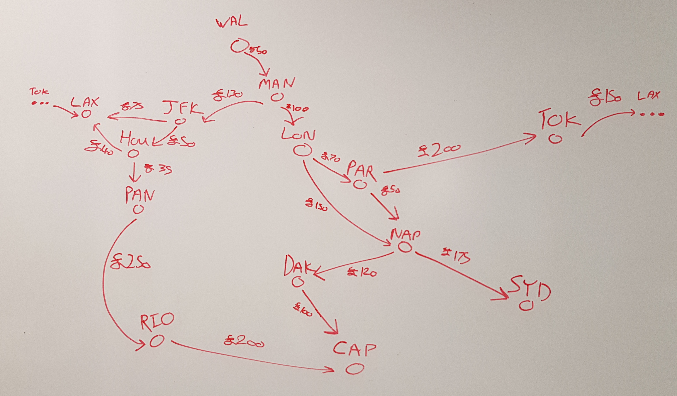

First, build this network within the main function of your program. You may copy and paste the code at the bottom of this document to quickly create this. (You may need to make some changes if your code slightly differs)

Once this network has been created, utilize the metrics implemented above the answer the following questions:

- What is the average number of connections present within the network?
- Which of these airports are the most interconnected?
- Which airport offers the cheapest flight?

Exercise 7

With our current structure, it is straight forward to obtain edges for a specified node to determine the available outbound edges for that node.

Implement a function that can find all the inbound edges available for a specified node.

Exercise 8

As previously discussed, graphs can be utilized in order to determine how something/someone could potentially traverse through the structure.

Using the lecture material, implement the DFS and/or BFS traversal functions into your graph.

Once this has been implemented, use the function(s) to determine which airports can be accessed, starting from:

- PAR
- JFK
- SYD

Exercise 9

Using the above functionality, some nodes can be identified as ‘mother vertices’ or nodes where it is possible to traverse to all other nodes from a starting node.

Implement a function that can determine this. You may wish to consider an approach that utilizes BFS or DFS.

Exercise 10 (Advanced)

Once we understand the context of which our graph structure is applied to, we can devise our own algorithms and metrics to address our enquires.

For the described graph above, implement an algorithm that displays a route from a starting specified node where you would always select the cheapest route available, without visiting the same airport more than once.

The algorithm should continue until no more options are available.

Exercise 11 (Advanced)

When analyzing graphs such as these, we may wish to determine what the shortest paths is available between two specified nodes, which we can implement as a function within our Graph class.

After determining if it is possible to traverse from node a to node b, calculate the shortest path length that is present between node a & b.

For this, you may want to consider a similar approach to BFS to implement this efficiently.

Exercise 12 (Advanced)

With a function to determine the shortest path between nodes, we can use the output of this functionality to calculate the closeness centrality metric for each node.

Implement a function that can calculate this value for a specified node (i), assuming:

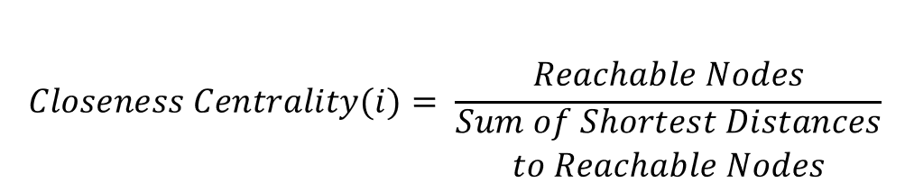

Then determine which of the airports has the highest closeness centrality value.

Exercise 6 Sample Code:

//You may need to change some things to fit with your solution...
testGraph.AddNode("WAL");
testGraph.AddNode("MAN");
testGraph.AddNode("LON");
testGraph.AddNode("PAR");
testGraph.AddNode("NAP");
testGraph.AddNode("SYD");
testGraph.AddNode("DAK");
testGraph.AddNode("CAP");
testGraph.AddNode("TOK");
testGraph.AddNode("JFK");
testGraph.AddNode("LAX");
testGraph.AddNode("HOU");
testGraph.AddNode("PAN");
testGraph.AddNode("RIO");

testGraph.AddEdge("WAL", "MAN", 50);
testGraph.AddEdge("MAN", "LON", 100);
testGraph.AddEdge("MAN", "JFK", 130);
testGraph.AddEdge("LON", "PAR", 70);
testGraph.AddEdge("PAR", "NAP", 50);
testGraph.AddEdge("PAR", "TOK", 200);
testGraph.AddEdge("TOK", "LAX", 150);
testGraph.AddEdge("LON", "NAP", 150);
testGraph.AddEdge("NAP", "SYD", 175);
testGraph.AddEdge("NAP", "DAK", 120);
testGraph.AddEdge("DAK", "CAP", 100);
testGraph.AddEdge("JFK", "LAX", 75);
testGraph.AddEdge("JFK", "HOU", 50);
testGraph.AddEdge("HOU", "LAX", 40);
testGraph.AddEdge("HOU", "PAN", 35);
testGraph.AddEdge("PAN", "RIO", 250);
testGraph.AddEdge("RIO", "CAP", 200);

